33333

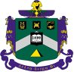
Delta Sigma Phi Alumni
Epsilon Rho Alumni Newsletter
Issue #31: Fall 2023
Brother Chris "Yabut" Patterson, W'73, Editor,
cpatterson76@outlook.com / 530-941-3986

The Sphinx Has Landed!

Delta Sig Has Returned To CAL POLY

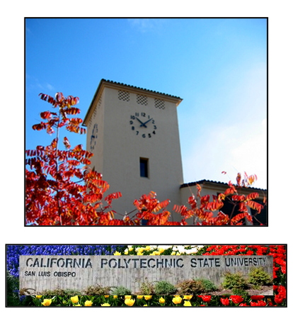

Recruitment For Our F'23 Class

Is Underway At Our Beloved Alma Mater

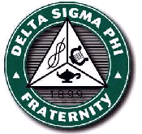
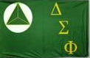



In This Issue:

RY "TOAST" BECK PROVIDES RESTART DETAILS

MEET OUR NEWEST ALUMNI VOLUNTEERS - CCAB ADVISORS

AA GIFTS TO FOUNDING CLASS

CHAPTER HISTORY TO BE STUDIED BY FOUNDING CLASS

UNIVERSITY'S "GREEK LIFE" PROVIDES INTERESTING IFC INFO

ALUMNI ASSOCIATION (AA) PRESIDENT'S MESSAGE

ALUMNI WIN AWARDS AT NATIONAL CONVENTION

OUR LONG-AWAITED RESTART REUNION IS MAY 9-11, 2024

HOW YOU CAN HELP

Editor's Note:

Brothers can find a great deal of Chapter info on AA's web site. Use the short-cut domain name of www.SLOYITBOS.com to reach www.CalPolyDeltaSigAlumni.com.

- "Newsletters and Reports" has thirty (30) past alumni newsletters;
- "ACB" and "Alumni Association" pages have officer contact information;
- "Our Chapter Today" has recent relevant messaging to prospective new members;
- "Update Contact Information" allows you to send Directory Manager Mike Harpo Roanhaus, S'70, your newest info so AA can keep you in-the-loop about alumni and chapter news.

RY "TOAST" BECK PROVIDES RESTART DETAILS
By Yabut In Consultation With Assistant Executive Director Toast

Paraphrasing Toast:

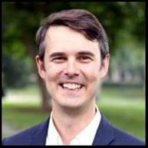
Advance recruitment has been underway, and trained HQ staff who specialize in recruitment will be on-campus from October 2nd through November 10th building the Founding Class.

The "Kick-Off Weekend" of concentrated training is Friday through Sunday, November 10-12th. During this intensely scheduled period, to give the Class time to study, train, and bond, alumni participation is limited. Only Alumni Advisors and Officers should attend, and even their role may need to be limited to help the program stay on schedule.

At this time initiation is planned for Sunday afternoon, November 12th, and is targeted to start between 3 and 5 p.m. Initiation takes about 2 hours and is only open to Brothers. Alumni are warmly invited to initiation and our dress code is coat and tie.

Brothers, wives, and guests are warmly welcome to attend any post-initiation celebration that we may plan in coordination with National. Epsilon Rho is discussing a post-initiation event but no decision has been reached.

MEET OUR NEWEST ALUMNI VOLUNTEERS - CCAB ADVISORS
By Yabut In Consultation With ACB President Peabody And Thanks To Our Advisors

Based upon our National Fraternity's experience in restarts, and assisting existing Chapters, Epsilon Rho is requested to establish an additional alumni oversight group as part of our restart plan.

The new group is called the CCAB (Collegiate Chapter Advisory Board). In this expanded Chapter oversight plan, the Chapter Advisor (previously called Chapter Supervisor) is now called the Lead Chapter Advisor.

ACB continues to own the Chapter's property, be responsible for the fraternal program, interface with our National Fraternity and alumni and Executive Officers, and perform strategic planning. The CCAB Advisors more frequently interact with undergraduate officers to assist them to understand and perform their offices' responsibilities. Each Advisor is responsible for a specific area of Chapter operations, such as Finance, Recruitment, Health, etc.

Based in part on the National CCAB sample model, and partly on extensive ACB/alumni discussions, at present Epsilon Rho has chosen six functional areas for Advisors to provide guidance. Arranged by the year of the Advisor's initiation, these are: Finance; Health; Operations; Recruitment and Retention; Social and Etiquette; and Campus Engagement.
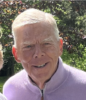
CCAB FINANCE ADVISOR
Tom "Woody" Brooks, W'73, CPA

Woody graduated from Cal Poly with a B.S. in Business Administration, Accounting Concentration, in 1974 with highest honors.

Woody retired in 2020 as a partner in Damitz, Brooks, and Nightingale and continues to reside in Santa Barbara.

Woody tells us, "In my role as an Alumni Advisor to the chapter restart, I will be interacting with the Treasurer and help him formulate ongoing financial procedures that will facilitate keeping the chapter on a sound financial footing going forward."

Woody has performed recruitment for his firm at Cal Poly in past years. He and his wife Judi, a Delta Sig Little Sister, are legacy parents. Their son Chad "Deuce" Brooks is an Epsilon Rho initiate, Spring 2002.

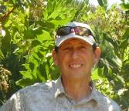
CCAB HEALTH ADVISOR
Dan "Froggie" Veyna, S'74, ASLA

Froggie directed his family's multi-state business with 165 permanent and 250 seasonal employees. He is a licensed Landscape Architect and created the Landscape Architectural firm of Sierra Design which now services clients throughout California and nationwide. His clients include the new Viticulture facility on the Cal Poly campus.

He tells us, "I earned my nickname by leaping to first place in the high-jump competition on Port San Luis Beach as a DSP pledge during Greek Week 1974. My wife Kathy and I both work from home and live in Los Osos, only 15 minutes from the fraternity house. I embraced DSP’s ‘Engineered Leadership’ and Cal Poly's ‘Learn by Doing’ mottos which have served me well with the challenges of life and career.

The friendships and life-long bonds forged while living at 244 California (Chapter house) have been and continue to be some of the most important and enduring of my life. I am excited to both give-back and pay-it-forward at Epsilon Rho."


CCAB OPERATIONS ADVISOR
Mark "Thumper" Hilleary, W'80

"I pledged DSP in Winter of 1980, served on Exec as Treasurer and then President, and graduated in the Spring of 1984 with a B.S. degree in Management Information Systems.

I currently live in Rocklin, California, but spent most of my career living and working in the Silicon Valley. With a background in software engineering and leadership, I spent four decades working for several Fortune 500 companies.

As a past Treasurer and President of Epsilon Rho, I’m very excited to share my fraternity operations experience with our new Brothers. The bottom line is the chapter needs to run like a small business providing services to its members. Like any company, it must have a trained management team to see that the chapter operates effectively and within its budget. I’m convinced that sound chapter management is one of the fundamental principles that drives the process of Brothers working together and forging the bonds of life-long brotherhood.

I'm certain that our new Epsilon Rho members will need the faithful support of our alumni base to reach their full potential. I’m looking forward to “paying the debt” by helping where I can."

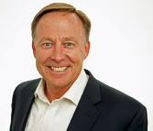
CCAB RECRUITMENT AND RETENTION ADVISOR
Rob "Custer" Yates, S'80

"I majored in Mechanical Engineering, lived in the house four years, and have been married to DSP's Dream Girl Gigi for 37 years.

During my Chapter days I was Sergeant At Arms, Rush Chair, Dog Chair (2 years), led Greek Week, played on a sports team every quarter, and had 4 great Little Brothers. I was IFC's first Rush Chair (for 2 years) and created Cal Poly's first rush booklet.

I filled every second of every day, and this taught me how to be disciplined with time management and to define and focus on objectives. This was all about teamwork with my brothers, and how – for example - all the sororities said that Delta Sigs were tops. We were confident, not cocky, and accomplished, not boastful. To this day, my best friends are my brothers from Epsilon Rho.

I attribute my personal and professional success largely to these Delta Sig years. I’ve been a part of Hewlett-Packard, SAP, Accenture; and Silicon Valley startups. They all are hungry for people that know how to assemble teams and deliver outcomes.

I am fortunate to have 2 children attend Cal Poly - 2008 to 2016. Son Rob Jr. “Rook” Yates is a Delta Sig and daughter Brooke is a Sigma Kappa. This showed me that things have changed, but the most important ones have not, including what you make of the journey is up to you!"

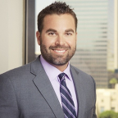
CCAB SOCIAL AND ETIQUETTE ADVOSOR
Brian "TRAX" Allee, F'99

My name is Brian Allee, TRAX, Fall 99, and I graduated in Spring 2004 with a degree in City and Regional Planning from the College of Architecture Engineering.

I am a Senior Project Manager/Director with Environmental Science Associates (ESA), a private consulting firm that specializes in community and airport planning, environmental planning, analysis, and assessment, natural and cultural resources management, environmental restoration and design, and regulatory compliance.

I have 18 years experience in project entitlements, urban planning, and preparation of environmental documentation and analysis compliant with the California Environmental Quality Act (CEQA) and the National Environmental Policy Act (NEPA).

I live in Huntington Beach and hope to assist our Chapter's program by providing accessible mentorship and guidance. I served two terms as Social Chair and can provide guidance on organizing social events for the brotherhood. I was an active brother for 4 years and will lend my knowledge and experience where needed."


CCAB CAMPUS ENGAGEMENT ADVISOR
Solomon "Ruby" Reda, F'07

After graduating from Cal Poly in 2012, I worked at Apple Inc for eight years, where I played a key role in launching products within the iOS and Machine Learning teams as a Program Manager. In 2019, I left Apple to embark on a few months of travel before joining a tech start-up as a Product Manager.

While an undergrad Delta Sig, I founded and served as DSP's first Alumni Relations Chair. DSP is where I was able to develop my leadership skills, where other brothers taught me about resumes and internships, and where I made lifelong friends.

On campus, I further developed leadership as part of WOW, served in student government (ASI) for three years, and co-founded one of my favorite groups, the Student Library Advisory Council. I fully embraced the opportunities offered by DSP and Cal Poly, and believe that these experiences have greatly contributed to my success after graduation.

DSP's Exec Board and Cal Poly Student Government played a significant role in my post-grad success! Drawing from my journey, I aspires to guide the men of DSP in their leadership roles within the fraternity and in the Cal Poly community - because I recognize the value of these experiences.

AA GIFTS TO FOUNDING CLASS
By AA Officers Mumbles (President) and Yabut (VP)

What alumni do and say will create an initial impression on our Founding Class's Brothers - an influence they will likely pattern on. We must be deliberate, purposeful, and most of all thoughtful in our messaging to them.

On behalf of our Delta Sig alumni from across seven decades, your Epsilon Rho Alumni Association has carefully and purposely chosen the following gifts for our Founding Class. Each represents a Brotherhood message.


The gavel represents the importance of leadership and of the Brotherhood's unity in values and actions.

History Boards, left to right: 676 Monterey / 1134 Palm / 244 California
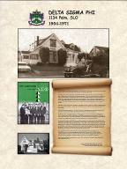
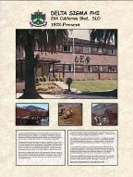
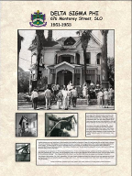

History boards represent the importance of knowing our Chapter's unique seven-decade journey. They promote our alumni hopes and aspirations for our Chapter's members, including future Brothers we may never meet. Reproduced on durable foam core board, they are lightweight, portable, and can be displayed on a wall or moved to rush events.

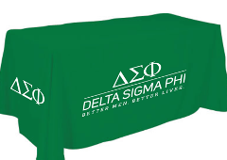
This beautiful DSP table cover represents the importance of growing and strengthening our membership by recruitment throughout the year as well as during IFC-approved formal rush periods. It represents the unending pursuit of finding a man better than yourself to enhance the Chapter's culture-of-character and personal growth.

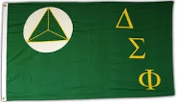
The DSP flag (sometimes called a banner) represents our Brotherhood and culture. Just as a country's flag is a rallying-point by standing for that nation's land, people, government, and culture, our Delta Sig flag represents our national social fraternity and our Brotherhood's core values, principles, and ideals.



A $1,000 check to establish a checking account represents the importance of a sound financial base to the achievement of a stable and successful chapter.



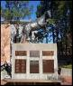
The gift of two new history boards - currently under construction - DSP's building the Poly P and donation to the Bronze Mustang, represent the importance of service-to-campus. They will provide points-of-pride with which to begin a recruitment conversation with a Better Man prospect. Lacking a chapter house and all our wonderful fraternal memorabilia during their first two years, our new Brothers can make good recruitment use of these highly popular on-campus displays - symbols of Delta Sig spirit and Brotherhood. DSP was the only fraternity to donate to the Mustang, and our name appears on the plaque just below "President Ronald Reagan".

And we are researching what DSP-lettered clothing item would best serve the goal of helping our Founding Class feel a greater sense of unity and bond during the first two years of probation. During this period they cannot live together in our Chapter house - and so it is leased.

By joining and donating to AA this Fall, you can be part of these and upcoming gifts to help the Chapter become established and successful.

CHAPTER HISTORY TO BE STUDIED BY FOUNDING CLASS
By AA Historian

With National Fraternity and ACB approval, AA is creating four 30-minute study session modules for the members of our Founding F'23 class to study during "Kick-Off Weekend", November 10-12. Key parts of the seven major history write-ups which cover different eras of Epsilon Rho, developed over the last 20 years by AA, are being summarized into this two-hour study assignment.

UNIVERSITY'S "GREEK LIFE" PROVIDES INTERESTING IFC INFO
By Your Editor

The University reports that last year there were eighteen (18) fraternities identified as IFC, and of these, six (6) had a chapter facility. Numbers for this academic year were not yet available.

Alumni Association (AA) President's Message
By Ray "Mumbles" Calande, W'74

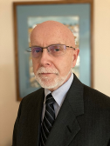
"As you are about to read, AA won the prestigious Hugh Cap Ryan Award at Convention. I accept this award on behalf of, and in thanks to, the alumni who have continued to donate their time and money to our organization. Several individuals stand-out in terms of the time they’ve donated to our continued success. We need to thank Mike “Harpo” Roanhouse. S'70, and Tom “Hooker” Gray, F'72, for their recent efforts in updating our alumni directory. We should thank Wayne “Dizzy” Kendrick, F'72, and his wife Wendi, for taking on the responsibility this year for our annual reunion dinner, and Mike "Harpo" Roanhaus for Co-Chairing next year's banquet with them, and running our charity golf tournament. Ben "Coco" Parcasio, S'74, deserves thanks for hosting the weekly Zoom get-together and for being our song leader, coordinator for Dream Girl, Pinnings, and reunion photographer.

We also need to thank Chris “Yabut” Patterson, W'73, and his wife Carol, for publishing our AA newsletters for over 20 years, for creating and managing our web site since 2008, for establishing and managing “The Poly P” scholarship program since 2012, for continuing to serve as our Epsilon Rho Historian, AA's Reunion Chair, and for representing our AA and members at the last six biennial National Conventions."

ALUMNI WIN AWARDS AT NATIONAL CONVENTION
By Your Editor

Eight alumni couples and six alumni attending stag represented Epsilon Rho at our National Convention - held in Austin, Texas, in July.

We honored our Bond Eternal Brothers Lurch Won The Herbert Award
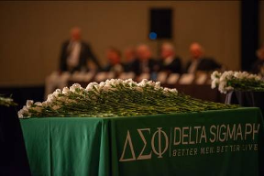
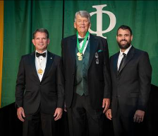

The Herbert Award is presented to members of the Fraternity who have performed an outstanding act for the good of the Fraternity, or whose diligence and persevering work have made them worthy of the award.

Lurch is only the second of 1,600 Epsilon Rho alumni to win this coveted award! Congratulations, well done, and long overdue Brother Larson!

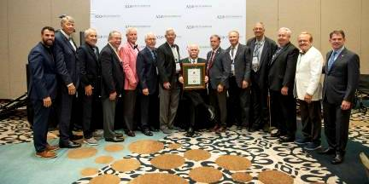
And Our Alumni Association Won Best In Nation - The Hugh Cap Ryan Award

Left to Right:
Executive Director Zippy, Grand Council Director W'72 Lurch, S'70 Ortho, F'73 Solo, F'69 Bull, F'72 Rollo, F'67 Deuce, W'73 Yabut (holding award), F'72 Dizzy, S'70 Harpo, F'72 Hooker, W'72 Tagam, S'74 IFUS, and National President Tom Archer. Missing from the photo are S'82 Killian and S'87 Walli.

Also attending Convention were Lurch's wife Greta, Solo's wife Gwenn, Bull's wife Linda, Rollo's wife Debbie, Deuce's wife Barb, Yabut's wife Carol, Dizzy's wife Wendi, and Hooker's wife Vicky.

The Hugh Cap Ryan Award: Assistant Executive Director Ry "Toast" Beck read the following presentation when awarding Epsilon Rho's Alumni Association this award:

"This award is presented to an alumni association or alumni chapter that has shown excellence in support of a local chapter or in strengthening the bonds of brotherhood in a particular geographic region.

Today, we are awarding an amazing alumni chapter that has made quite the name for themselves - last winning this award at the 2009 Convention!

Known today for their incredible bond and unique nicknames, this alumni chapter organizes annual gatherings with members and partners, they print multiple alumni newsletters every year, and they keep an ongoing scholarship, “The Poly P”, with their university.

This year, specifically, the Epsilon Rho is deserving of this award for undertaking one of the largest alumni directory updates we’ve ever seen. They tracked down alumni from every generation, not with a single email blast, but with endless calls and letters in a wild phone tree that found brothers who had been disconnected for decades.

And finally, they have served as an amazing partner to their alumni corporation board and our national headquarters as we prepare to welcome the next generation of undergraduate members to their chapter this fall."

Save-The-Date: The next National Convention will be in Denver, Colorado, summer 2025.

OUR LONG-AWAITED RESTART REUNION IS MAY 9-11, 2024
By AA Reunion Chair Yabut


THURSDAY, MAY 9: Practice golf round in Nipomo followed by BBQ and garage party for golfers and non-golfers at W'72 Larry "TA" Everett's home: 1050 La Serenata Way, Nipomo. TA 805-550-2459. A great "just hit town" kick-off event for everyone! BBQ Contact: Ben "Coco" Parcasio at benqparcasio16@gmail.com / 831-206-5536.


FRIDAY, MAY 10: DSP's 11th annual 21st Century Fund Golf Tournament in Nipomo will provide scholarships and training to new members via DSP Foundation. Player cost will be around $100 and "Tee" Sponsorships of $200 and "Executive" Sponsorships of $500 help fund scholarships and training.
Contact: Mike "Harpo" Roanhaus, S'70, at Mike.Roanhaus@gmail.com / 650-465-5930.


SATURDAY, MAY 11: ACB will be held at a time and place to be announced - and probably at Embassy Suites in SLO.


SATURDAY, MAY 11, 6-10 p.m.: Carnation Ball for alumni, undergrad Brothers, and guests. Embassy Suite Ballroom, RSVP / Pre-Payment.
Contact: Banquet Co-Chair Wayne "Dizzy" Kendrick, F'72, whkendri@gmail.com / (214) 755-0468; or Co-Chair Wendi Kendrick, Wendi.Kendrick@gmail.com / (469) 585-7829; or Co-Chair Mike "Harpo" Roanhaus, S'70, Mike.Roanhaus@gmail.com / 650-465-5930.


THURSDAY THROUGH SATURDAY NIGHTS, MAY 9-11: AA has negotiated a block of 30 discounted rooms at Embassy Suites in SLO.
Contact: Chris Yabut Patterson, cpatterson76@outlook.com / 530-941-3986.

HOW YOU CAN HELP

After far too many years, our first "restart" class is being recruited!


In about 6 weeks our new young Brothers in Fall '23 will have faces,
but not much else to begin rebuilding Delta Sigma Phi.

No matter their class size, for the next two years they will NOT have
a Chapter House to live in, eat meals together, gather at, and invite guests to.

If there ever was a time when Delta Sig undergrads needed help, it is now -
and for two more years.

Please ask yourself, "Other than Delta Sigs, who will help them?"

Please help them by joining and donating to AA.

We will help them bridge this two-year gap and
rebuild our YITBOS program, pride, and bond.

Their success will be our success!

How To Join By Surface Mail:

Make Your Check Payable To: DSP EP Alumni Assn. and mail it to "DSP EPSILON RHO ALUMNI ASSOCIATION" at PO BOX 610743 in SAN JOSE CA 95161-0743. It is important to put your return address on the envelope. Please do not send cash. AA President and Treasurer Ray "Mumbles" Calande, W'74, will receive and process it. Please print and include this page.

How To Join Electronically:

Go to PayPal.com, follow instructions, and give to:
dsp_at_calpoly@att.net.

With sincere thanks and YITBOS, W'73 Yabut and W'74 Mumbles
AA Officers Since The Organization's 2001 Founding

